D.A.V. PUBLIC SCHOOL, AIROLI

**CHEMISTRY INVESTIGATORY PROJECT**

# **VINEGAR TITRATION**



|  |
| --- |
| Name:  Class:  Board Roll No.: |

**ACKNOWLEDGEMENT**

I, would like to express my gratitude to all those who gave me the chance to do this wonderful project. A sincere thanks to our Principal **Mrs. Suman Pradhan** for supporting and motivating us during the course of our project. We are thankful to our Chemistry teacher **Mrs. Balvinder Chumber** and our school’s chemistry lab assistant, **Ms. Swati Patil,** who guided us throughout the project by giving suggestions and encouraging us.

I am also grateful to my teammates for their inputs and help provided to complete the project in time. Lastly, a big thanks to my parents and friends who helped me complete the project.

**CERTIFICATE**

This is to certify that, **TEJASWINI GAIKWAD of** Std. **XII-A**, D.A.V. Public School, Airoli has successfully completed and demonstrated the afore mentioned activity on VINEGAR TITRATION in the session 2023-24. It is further certified that the project is genuine work of the student and has been done sincerely and satisfactorily.

External Examiner School Stamp Internal Examiner

**INDEX**

|  |  |
| --- | --- |
| **S.NO** | **TABLE OF CONTENTS** |
| 1. | INTRODUCTION |
| 2. | AIM OF THE EXPERIMENT |
| 3. | MATERIALS REQUIRED |
| 4. | THEORY |
| 5. | PROCEDURE |
| 6. | DEMONSTRATIONS & CALCULATIONS |
|  | 1. WITH APPLE CIDER VINEGAR 2. WITH WHITE VINEGAR |
| 7. | OBSERVATION TABLE |
| 8. | RESULT |
| 9. | CONCLUSIONS |
| 10. | PRECAUTIONS |
| 11. | BIBLIOGRAPHY |

**INTRODUCTION**

* **Vinegar:** a sour-tasting liquid, is produced through the fermentation of ethanol by acetic acid bacteria. It comes in various types, each offering distinct flavours for culinary use. Traditionally, it has been linked to potential health benefits such as aiding digestion and regulating blood sugar levels.

Its acidic nature also makes it a natural preservative, preventing bacterial growth in pickled foods. Moreover, it is a popular choice for eco-friendly cleaning solutions due to its ability to break down grime.

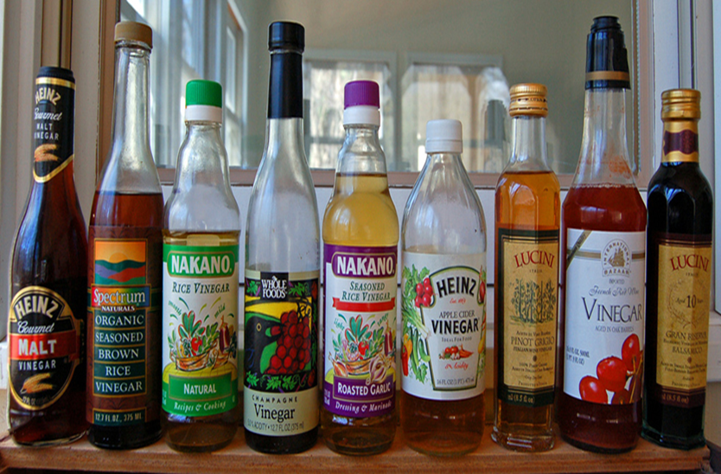

* **Titration**: is a laboratory method of quantitative analysis used to determine unknown concentration of known substance.

Analysis is performed using a burette, a kind of laboratory glass made for exact measurement of volume of solution used. The most popular titrimetric experiment is the determination of an amount of an acid in solution.

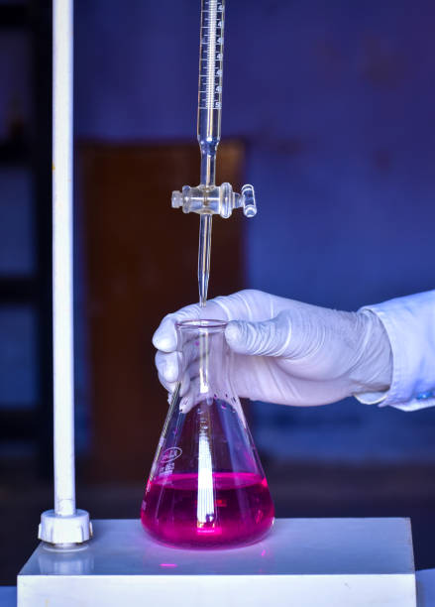

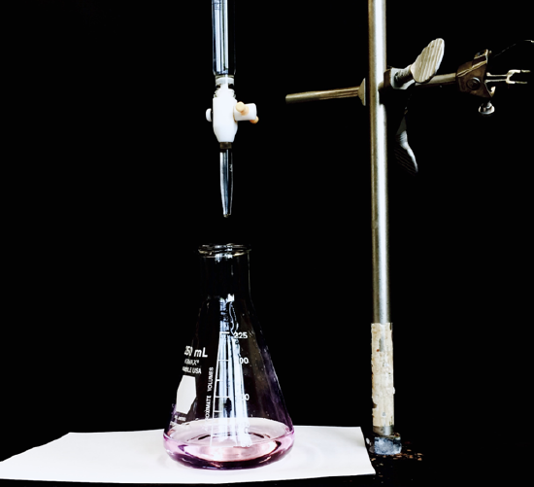

* **White Vinegar**: Historically, white vinegar has been produced from the fermentation of foods such as sugar beets, potatoes, molasses or milk whey. White vinegar has many uses: cooking, baking, cleaning, and even weed removal. It may also aid with weight loss and controlling cholesterol and blood sugar control. However, it should be used in moderation.
* **Apple Cider Vinegar**: Apple cider vinegar is made through a process called fermentation. The process has two steps. First, the apples are crushed, and yeast is added to speed up the fermentation process, so the sugar converts into alcohol after a few weeks. Then, natural bacteria break the alcohol down into acetic acid, which gives vinegar its tangy taste and odour.

It is used in salad dressings, marinades, vinaigrettes, food preservatives and chutney.

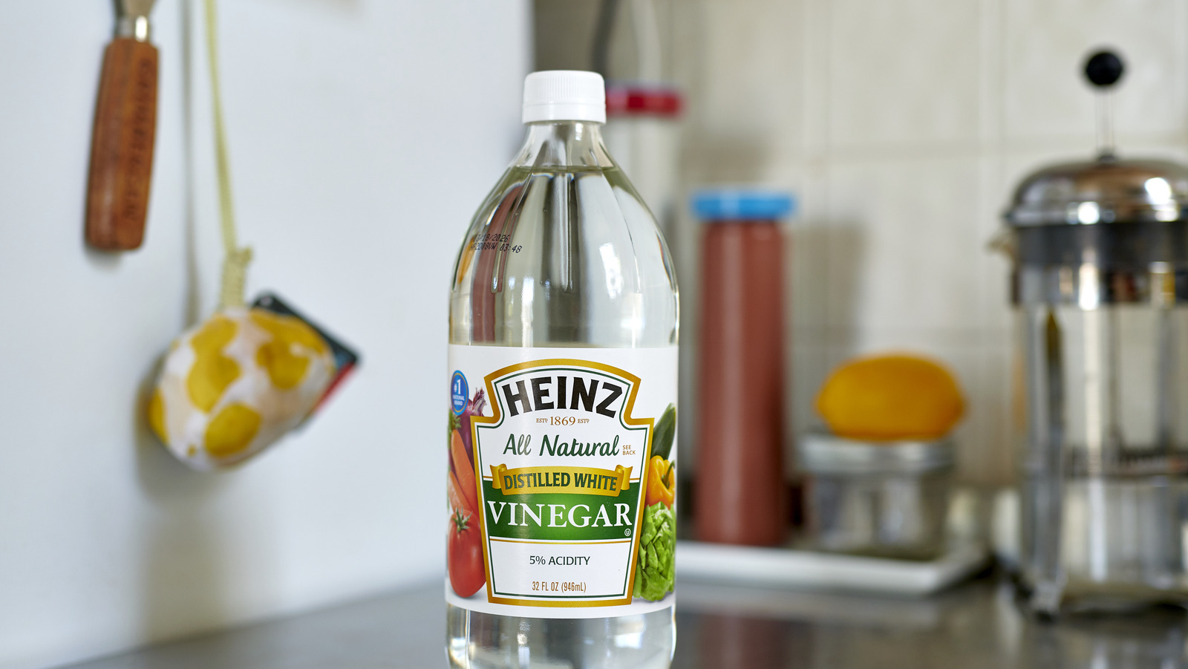

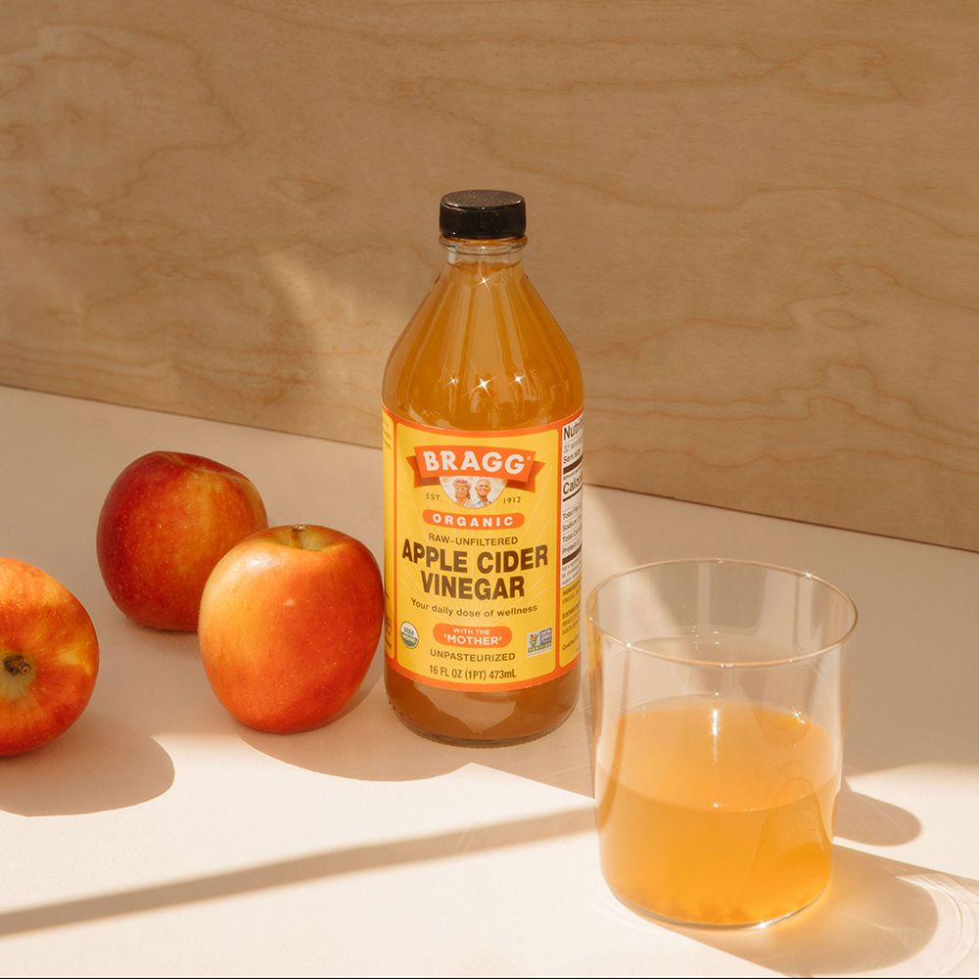

**AIM OF THE EXPERIMENT**

To determine the strength of acetic acid

(CH3COOH) in two different types of vinegar by using 0.1M of sodium hydroxide (NaOH) solution and phenolphthalein indicator.

And to conclude which of the two vinegars has the lowest strength of acetic acid, thereby having minimum negative effects over general body health.

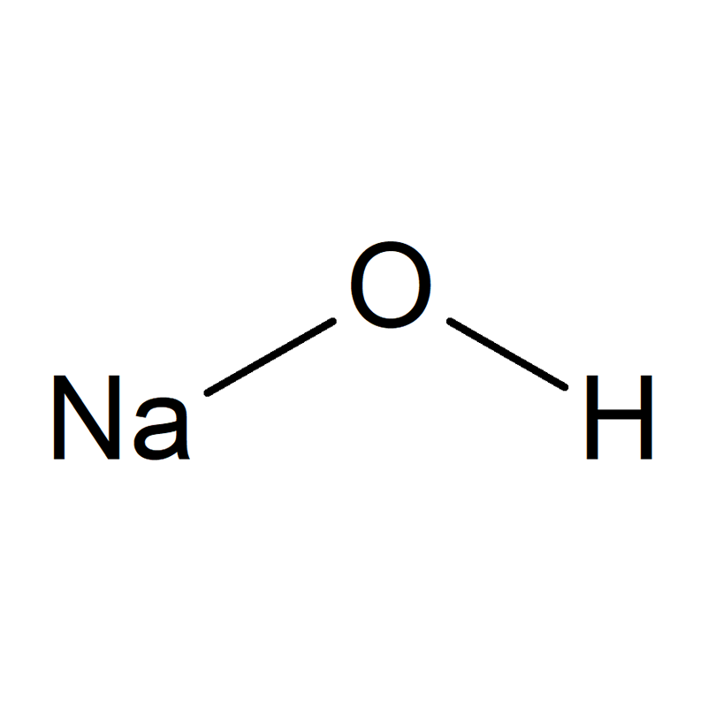

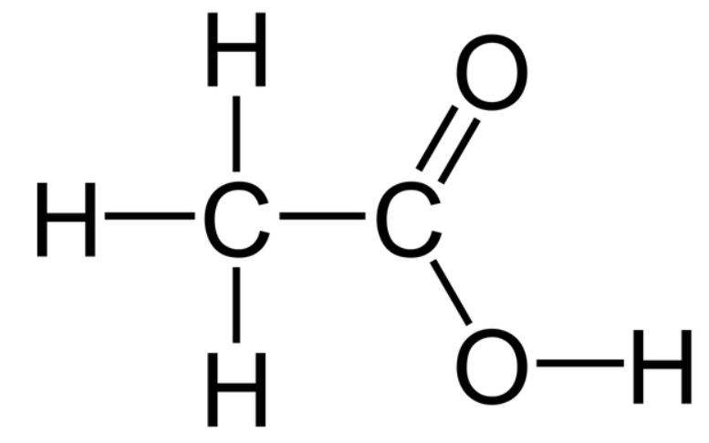

**MATERIALS REQUIRED**

* **APPARATUS REQUIRED:**

1. Small funnel
2. 250ml Conical flask
3. 100ml burette
4. Burette clamp and Ring stand
5. 10ml Graduated Cylinder
6. Dropper/Stop cock
7. 200ml Graduated Beaker
8. 100ml Graduated Beaker

* **CHEMICALS REQUIRED:**

1. Distilled water
2. 0.1M solution of NaOH
3. 0.5% Phenolphthalein solution in alcohol
4. White Vinegar
5. Apple Cider Vinegar

**THEORY**

The method used to measure the total acidity of the vinegar being studied is called an acid-base titration. For an acid-base titration, the known chemical reaction in general is:

**acid + base → water + salt**

For our experiment the following specific reaction will be used:

**HC2H3O2(aq)+ NaOH(aq) → H2O(l) + NaC2H3O2(aq)**

The end point in this reaction will be detected with an acid/base indicator. Phenolphthalein is the indicator used in this experiment. It changes colour while the drops of sodium hydroxide are added.

Molarity(M) = **Moles of acetic acid/Volume of solution**

or as a mass percent,

Mass %age = **Mass of acetic acid x100/Mass of vinegar**

**PROCEDURE**

**1.** **Setting/preparing the burette for titration with NaOH**

1. Rinse the inside of the burette with distilled water. Allow the distilled water to drain out through the tip so that the tip is also rinsed.
2. Now similarly, rinse the burette with a small amount of NaOH.
3. Fill the burette with NaOH up to the top, where the 0mL mark is located. Use a 100mL graduated beaker for this. Pour the NaOH through the funnel to do this carefully, below eye level.

**2.** **Preparing the Vinegar O.S**

1. First, rinse the inside of the volumetric flask and graduated beaker with distilled water.
2. Take 5mL of the vinegar sample in a graduated cylinder and pour it in the 200mL graduated beaker.
3. Now, fill the graduated beaker with distilled water up to the 50mL mark in order to dilute the vinegar. Mark this as O.S. (original solution).
4. Take 10mL of this O.S. in a graduated cylinder and pour it in the conical flask.
5. Record this volume of vinegar.
6. Add 5 drops of phenolphthalein indicator to this flask with a dropper/stopcock and shake gently.

**3.** **Titration**

1. After adding phenolphthalein indicator to the flask. We can start with the titration.
2. Loosen the stopcock a little, to let NaOH drip into the cylinder slowly while you swirl it constantly.
3. As the NaOH is added, the colour changes but reverts back soon while it is being swirled.
4. After some time, there is an endpoint when a permanent colour change is observed. Tighten the stopcock at that point and take readings from the burette.
5. The volume of the NaOH delivered is to be recorded.
6. 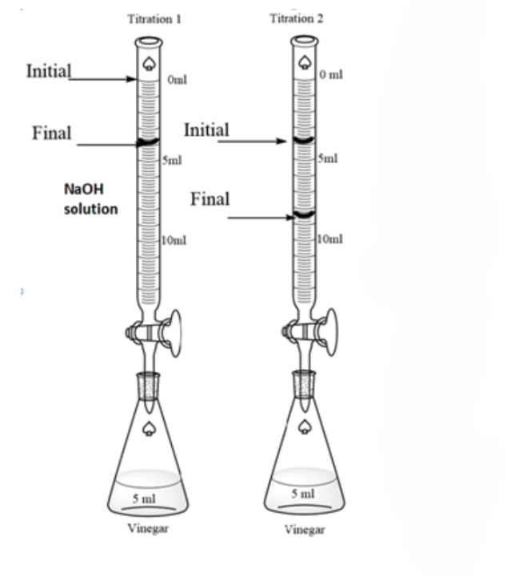Repeat the same steps until 3 same readings are observed i.e., concordant reading.

**DEMONSTRATIONS AND CALCULATIONS**

**For White Vinegar**:

**OBSERVATION TABLE**

**For White Vinegar**

|  |  |  |  |
| --- | --- | --- | --- |
| **SR.NO** | **INITIAL BURETTE READING** | **FINAL BURETTE READING** | **VOLUME OF NaOH USED** |
| 1. | 0.0mL | 14.6mL | 14.6mL |
| 2. | 14.6mL | 29.2mL | 14.6mL |
| 3. | 29.2mL | 43.8mL | 14.8mL |

Concordant Reading:14.6mL

**For Apple Cider Vinegar**

|  |  |  |  |
| --- | --- | --- | --- |
| **SR.NO** | **INITIAL BURETTE READING** | **FINAL BURETTE READING** | **VOLUME OF NaOH USED** |
| 1. | 0.0mL | 11.0mL | 11mL |
| 2. | 11.0mL | 22.4mL | 11.4mL |
| 3. | 22.4mL | 33.4mL | 11mL |

Concordant Reading: 11mL

**SHORTCOMINGS**

We are aware that even with the best of our efforts, discrepancies can occur in our experiment. The following are some certain ones:

* If a particular vinegar has a lower content of acetic acid, it isn’t necessarily a healthier option. Certain factors like the brand genuinity and quality assurance plays a role here. We overlook this fact here.
* The two samples of vinegar taken might belong to different manufacturers and hence their relative strength may not match if they were taken from a fourth manufacturer.
* Since the results depend on the brand genuinity and manufacturer, these results are not absolute for the class of vinegars and are limited to the samples we have utilised.

**PRECAUTIONS**

1. Treat every unknown chemical as if it were hazardous.
2. Do not taste or smell any chemical.
3. Never use an open flame in a lab without the supervision of the TA.
4. Check the apparatus for cracks/chips.
5. Rinse the flask and burette with distilled water, before and after use.
6. Sodium Hydroxide (NaOH) is light, so always read the lower meniscus.
7. Take concordant readings and don’t go with average readings.
8. Do not return the chemicals to the reagent bottles. Try to take an optimum amount of the required reagent.
9. Try to keep the work area decluttered.
10. Follow the rules for proper disposal of chemicals.

**BIBLIOGRAPHY**

* <https://studymind.co.uk/>
* <https://openai.com/blog/chatgpt/>
* <https://www.sciencebuddies.org/>
* <https://chem.libretexts.org/>
* <https://vlab.amrita.edu/>
* ht[tps://google.com/](https://google.com/)
* <https://wikipedia.org/>